**Editing Basics**

|  |
| --- |
| 1. Create a folder called **Editing_basics**. On DIA 322 computers, you might want to create this folder in your user Documents folder (e.g. C:\Users\jdoe\Documents\Editing_basics). On the DIA 222 computers, you might want to create this folder on the D: drive under D:\course number\user name\ (e.g. D:\ES212\jdoe\Editing_basics). 2. [Download the data](Editing_basics_files/Editing_basics.zip) for this exercise then [extract the contents](Opening_zip_files.htm) of **Editing_basics.zip** into your newly created **Editing_basics** directory. |

In this exercise, you will be introduced to a few of ArcGIS’ editing tools. You will learn how to create and edit polygon and polyline data. You will also learn how to avoid certain editing pitfalls such as the inadvertent creation of “donut holes”.

Contents

Step 1: Open your Map Session 2

Step 2: Create a new polygon feature 2

Step 3: Digitize a new polygon feature 7

Step 4: Creating a new feature template 11

Step 5: Adding a field to an existing layer 13

Step 6: Splitting an existing polygon 16

Step 7: Editing the attributes table 20

Step 8: Adding an ‘Island’ polygon 22

Step 9: Creating adjoining polygons 29

Step 10: Setting up the snapping environment 32

Step 11: Adding vertices to a polyline 33

Step 12: Extending line segments 37

Step 13: Adding polyline segments 40

Step 14: On your own 43

1. Open your Map Session

Navigate to your **Editing_basics** folder and double-click the **Editing_basics.mxd** file.

This will launch your new ArcMap session. You should see an aerial image of the Colby Campus.

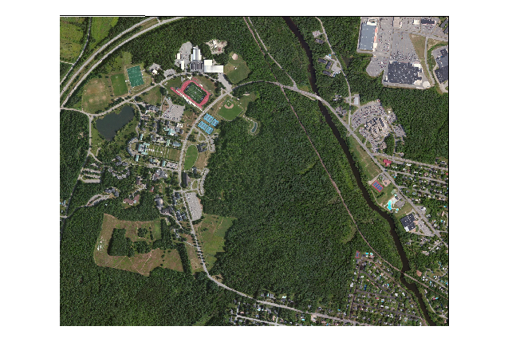

Your first task will be to digitize Johnson Pond.

1. Create a new polygon feature

Before you begin your first digitization task, you will need to create a new polygon feature in the Data.gdb file geodatabase.

To the right of the data view window, click on the **Catalog** tab.

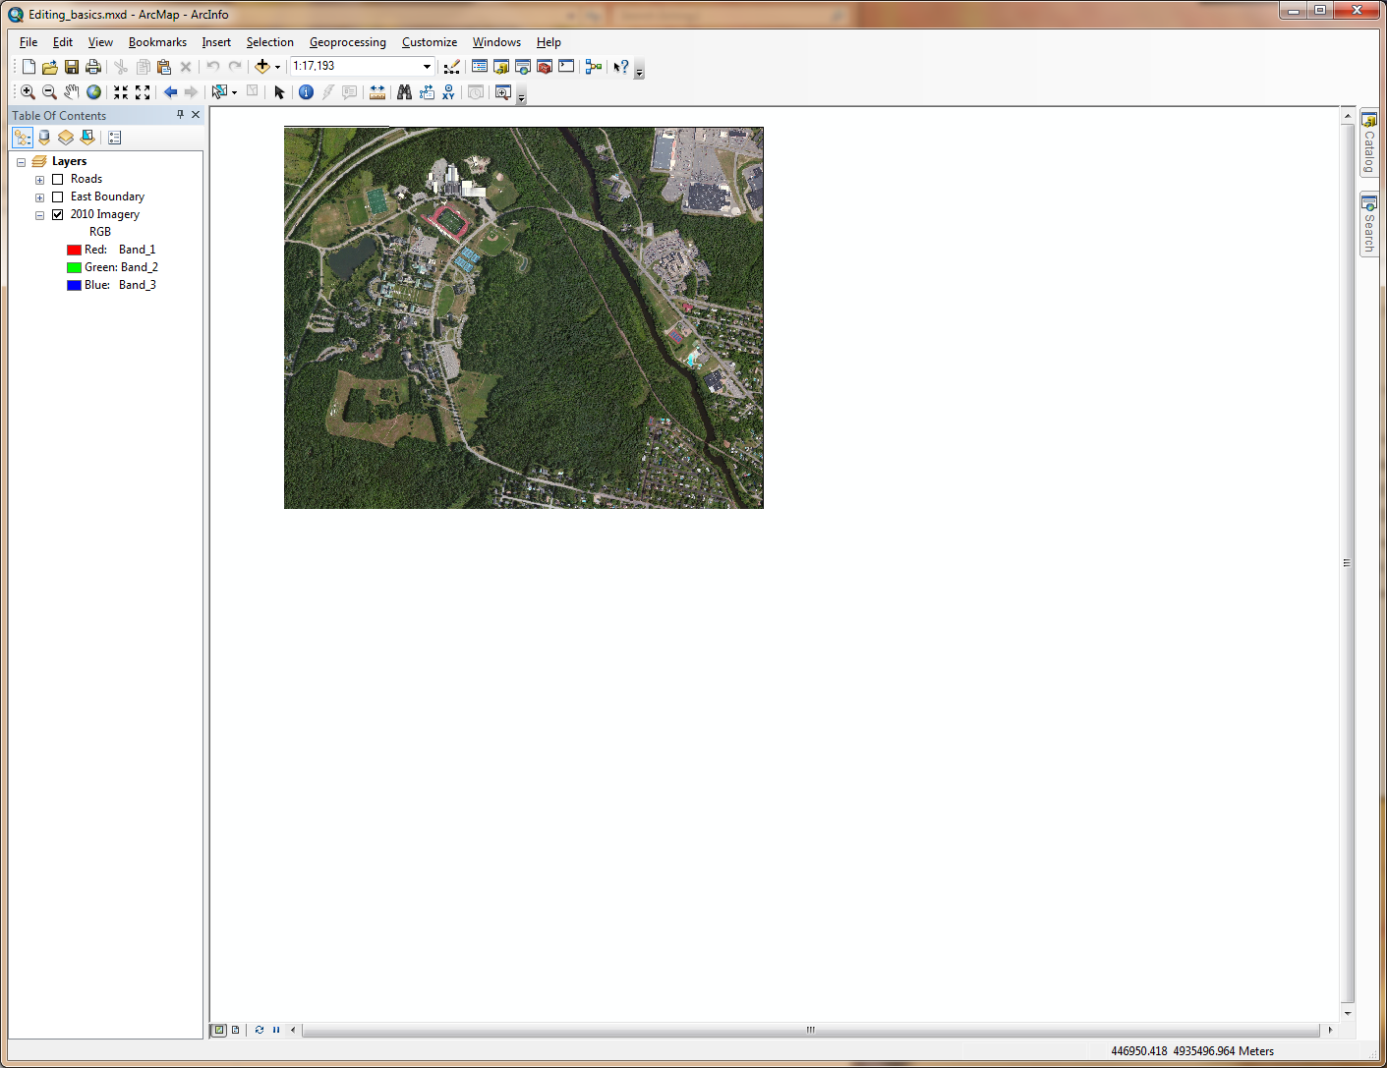

In the Catalog window, **right-click** on the **Data.gdb** geodatabase and select **New >> Feature Class**.

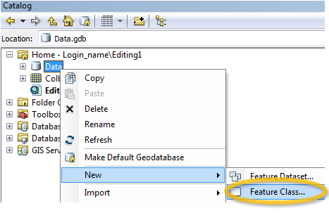

In the New Feature Class window, name the new feature **JohnsonPond** (make sure *not* to add spaces) and make sure that **Polygon Features** is selected as the feature type.

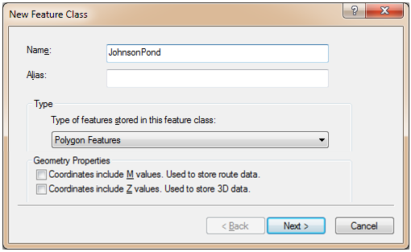

Click **Next**.

Select **Projected Coordinate System >> UTM >> NAD 1983 >> NAD 1983 UTM Zone 19N** as the new feature’s coordinate system (this is a popular coordinate system for the State of Maine).

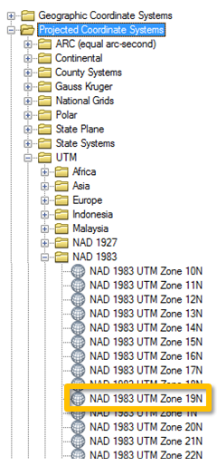

Click **Next**.

Keep the default XY Tolerance settings.

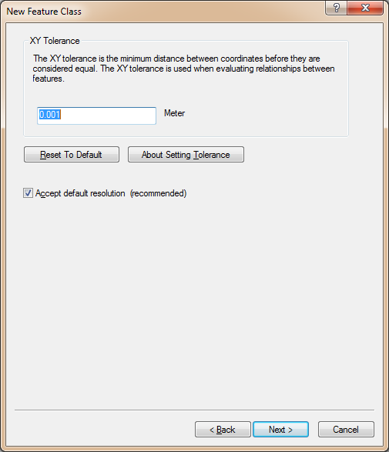

Click **Next**.

Keep the default database storage configuration.

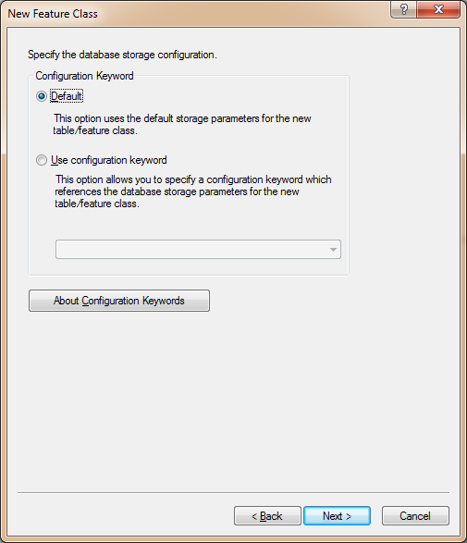

Click **Next**.

In the *Field Name* column, add a new field called **Name**. In the *Data Type* column, assign the new field set the data type to **Text** data type. Make sure that the text length is set to **50**.

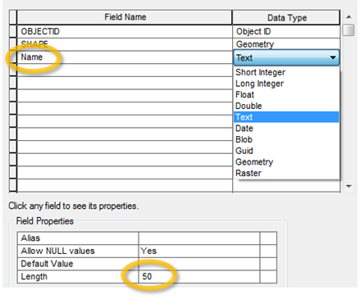

Click **Finish**.

You just created a new (empty) polygon feature class in the Data.gdb geodatabse. ArcMap automatically adds the new feature class to your list of layers in the TOC.

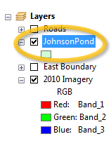

Note that you can also create a new shapefile following the same procedure except that you would right-clicking a *folder* instead of a *geodatabase*.

The JohnsonPond layer is currently empty. In the next step you will create a new polygon feature for that layer.

1. Digitize a new polygon feature

In the **Bookmarks** pull-down menu, select **Johnson Pond**.

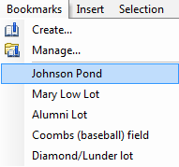

Your map extent should now be restricted to the Johnson Pond water body.

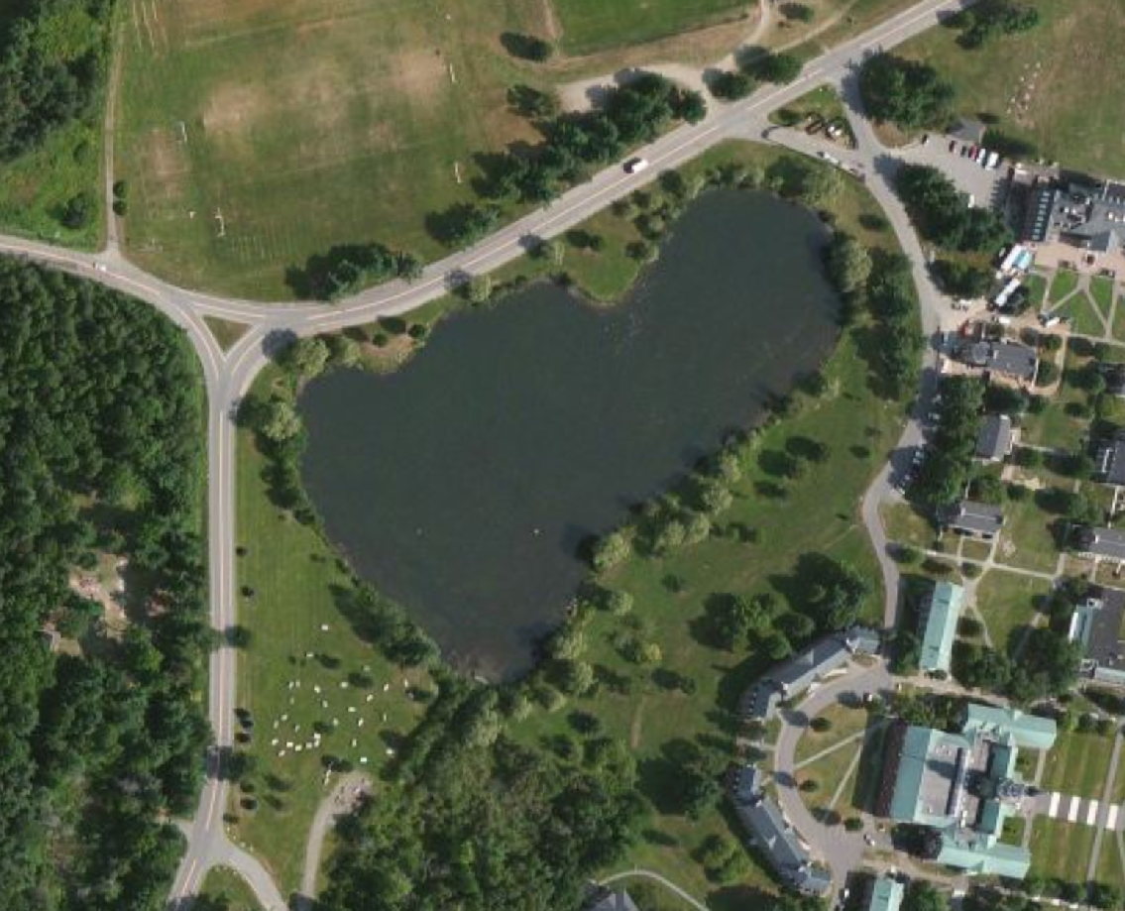

In the next step, you will set the JohnsonPond layer’s transparency to 50%. This will be helpful when digitizing non-linear features since having a non-opaque feature will facilitate seeing the underlying pond as you digitize.

**Right-click** on the JohnsonPond layer and select **Properties**.

In the Layer Properties window, select the **Display** tab and set the **transparency** to **50%**.

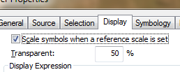

Click **OK** to close the Layer Properties window.

Next, you’ll start the edit session.

**Right-click** on the **JohnsonPond** layer and select **Edit Features >> Start Editing**.

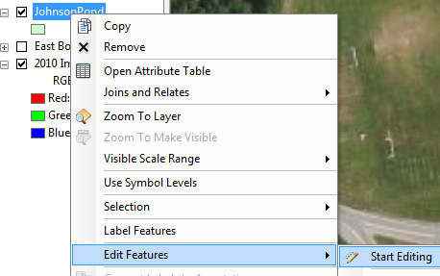

When you start an edit session, a Create Features window pane pops up on the right-hand side. The Create Features window lists all editable layers, and displays the corresponding map symbol next to each layer. These are known as feature templates.

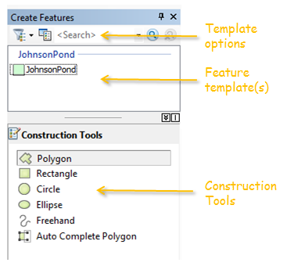

Select JohnsonPond in the Create Features window.

A list of construction tools will appear at the bottom of the window.

Select **Polygon**.

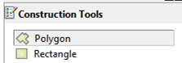

You digitize polygons by creating vertices. The vertices define the *points* for each line (or edge) defining a polygon.

Move your mouse pointer anywhere along Johnson Pond’s shoreline and **left-click**. This creates the first **vertex**.

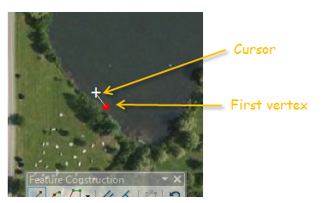

Continue adding vertices along the edge of the pond. The vertices define the polygon boundary.

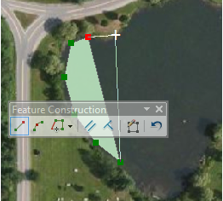

|  |
| --- |
| Here are some digitizing tips you might find helpful:   * To **pan** around the map during an edit session, **click** and **hold** the **middle mouse button** (wheel) * To **zoom in** our **out** of the map during an edit session, **scroll** the mouse **wheel** * If the **Feature Construction toolbar**  gets in the way, click on the Tab key to reposition it * If you make a mistake while digitizing, press **ctrl+Z** keys to undo the last edit * To delete an ongoing edit, **right-click** and select **Delete Sketch**. |

After adding the last vertex, **right-click** and select **Finish Sketch** (alternatively, you can press the **F2** key). This step finalizes the creation of the new polygon.

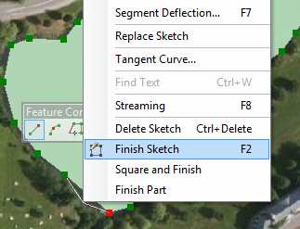

Digitized features **do not** get saved to the data file (shapefile or geodatabase) until you **explicitly** instruct ArcMap to do so.

In the **Editor** toolbar, click on **Editor >> Save Edits**.

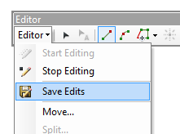

Next you will edit an existing polygon (aka feature class).

1. Creating a new feature template

**Right-click** the **East Boundary** layer and select **Zoom to Layer**.

Make the East Boundary **visible** in your data view (i.e. check the East Boundary box in the TOC)



Note that once you made the East Boundary layer visible in the map document, its feature is added to the Create Features template. This is because the East Boundary feature class resides in the same workspace as JohnsonPond (i.e. …\Editing1\Data.gdb).

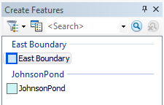

All feature class or shapefile in a common workplace can be accessed within a same edit session. This can pose a problem if the wrong feature is selected in the Feature Templates. It is therefore best to remove (or turn off) all layers not used in an edit session. In this case, we will turn off JohnsonPond so that we don’t accidently edit it.

In the **TOC**, **turn** **off** (uncheck) **JohnsonPond**.

Your Create Features window should now only display East Boundary.

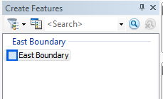

Next, we will add a new field to the East Boundary feature class.

1. Adding a field to an existing layer

Open East Boundary’s attribute table by **right-clicking** on the layer in the TOC and selecting **Open Attribute table**.

New fields can be added in the Table window, however if you are in an edit session, you will notice that the **Add Field** is ghosted out.

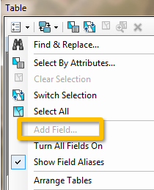

We therefore need to temporarily stop the edit session in order to add a new field.

From the **Editor** toolbar, select **Editor >> Stop Editing**.

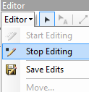

In the attribute table window, select **Add Field** from the **Table Options** pulldown list .

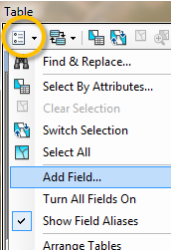

In the Add Field window, name the new field “**Type**” and make it a “**Text**” field and set the length to 50 characters.

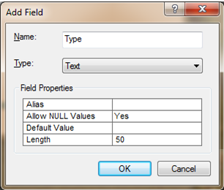

Click **OK** to close the Add Field window.

**Close** the attributes table.

Restart the edit session by **right-clicking** the **East Boundary** layer and selecting **Edit Features >> Start Editing**.

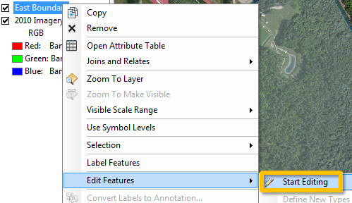

1. Splitting an existing polygon

In this step, you will delineate the wooded section of the eastern boundary. Since an existing polygon covers the area-of-interest, we do not want to create a new overlapping polygon. Instead, we will split the existing polygon.

In the Editor toolbar, click on the **Selection** tool .

In the Data View window, **select** the East Boundary polygon.

The polygon edge should be highlighted in cyan.

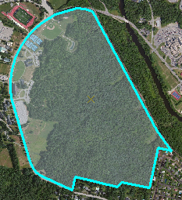

In the **Editor** toolbar, select **Cut Polygons** tool.

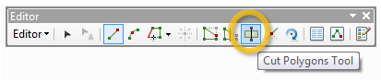

**Zoom in** to the southern section of the wood/field boundary.

**Hover** the cursor over the edge of the East Boundary layer until you see the cursor **“snap”** to the boundary line (a square box will indicate when the cursor is snapped to the boundary edge).

This ensures that the first digitized vertex is interpreted as belonging to the existing boundary edge. If the first vertex does not snap to the existing edge, the split polygon may fail.

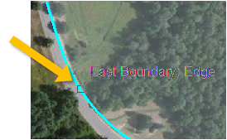

With the cursor snapped to the edge, **click the left mouse button** to add your first vertex.

Delineate the wood/open area by adding vertices.

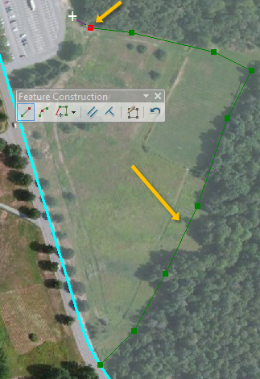

|  |
| --- |
| Here’s a reminder of digitizing tips you might find helpful:   * To **pan** around the map during an edit session, **click** and **hold** the **middle mouse button** (wheel) * To **zoom in** our **out** of the map during an edit session, **scroll** the mouse **wheel** * If the **Feature Construction toolbar**  gets in the way, click on the Tab key to reposition it * If you make a mistake while digitizing, press **ctrl+Z** keys to undo the last edit * To delete an ongoing edit, **right-click** and select **Delete Sketch**. |

When you reach the northern edge of the boundary, hover your mouse cursor over the edge until you see the cursor **snap**, then **click** on the **left mouse button** to place your last vertex.

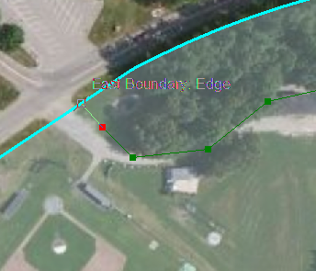

To **finish** the sketch, **right-click** anywhere on the map and select **Finish Sketch** (or press the **F2** key).

The East Boundary polygon is now split into two non-overlapping polygons.

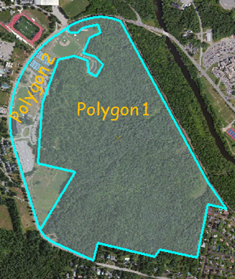

Next, you will assign attribute values to both polygons.

1. Editing the attributes table

Make sure that both polygons are still selected (they should both be outlined with a bright cyan color).

If your attribute table is not open go to the **Editor** toolbar and open the **Attributes** table.

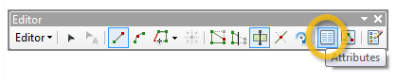

The Attributes table will open in the right hand side of the ArcMap window.

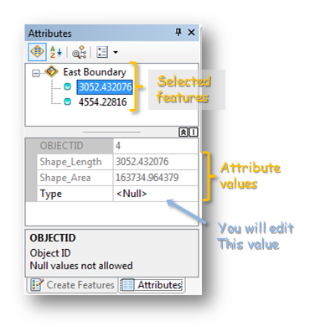

All selected polygons will be listed in the Attributes table editing environment. You should see two features. They are identified as their polygon perimeter (ArcGIS defaults to the first attribute value found in the attribute table).

**Click** on the **top** feature. This will highlight the left most polygon.

In the **Type** field, enter **“Open area”.**

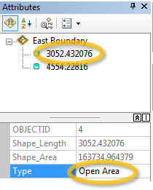

Select the other polygon and enter **Wooded** for its **Type**.

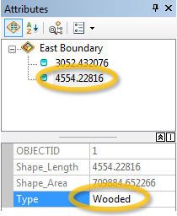

In the next step, you will digitize the Colby Green elliptical lawn.

1. Adding an ‘Island’ polygon

In the previous step, you learned how to split a polygon into two sections. This required that the new polyline segment intersect the original polygon at **two** boundary points. But what if you need to create a new ‘Island’ polygon feature within the original polygon? The split tool will not work since you don’t have a boundary to snap to. You therefore will need to create a new polygon using the Polygon construction tool. But as you will soon find out, this approach has a serious pitfall that will need to be resolved.

At the bottom of the Attributes window, click on the **Create Features tab**.

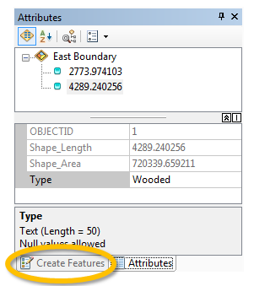

Note that you can toggle back and forth between the Attributes editor and the Creature Features window via the bottom tabs.

Clear all selected features by clicking the **Clear Selected Features** tool from the **Tools** toolbar.

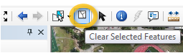

Make sure that East Boundary is selected in the **Create Features** window then select the **Polygon** tool from the Construction Tools list.

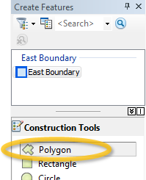

In the Data View window, digitize the Colby Green elliptical lawn. Follow the same techniques you used to digitize Johnson Pond in an earlier Step.

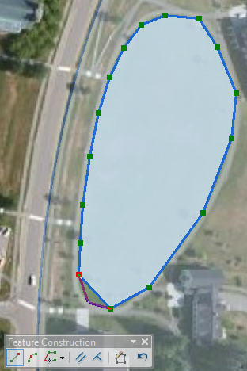

After you finish the Sketch, go back to the **Attributes editor** window.

From the **Editor** toolbar select **Edit Tool**.

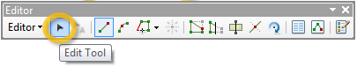

In the Data View window, **select** the polygon you just create.

After you select the polygon you will see the **Selection Chip** tool  appear. This tool appears when more than one feature is selected. It allows you to fine tune your selection.

Expand the **Selection Chip**.

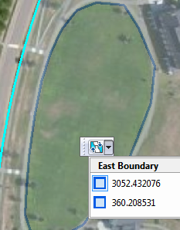

In our example, you have two polygons sharing the exact same space! In most cases, you do not want polygons within a same layer to overlap. By hovering over either one of the displayed features, the associated polygon will highlight in the Data View window.

**Select** the Colby Green polygon. This should be the second one on the list (note that the values displayed may differ from yours).

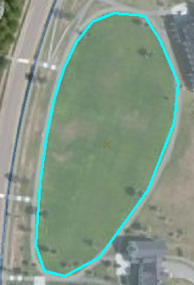

In the Editor toolbar, select **Editor >> Clip**.

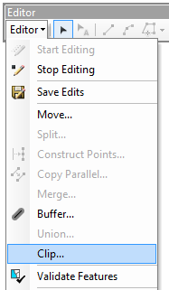

In the Clip tool set the Buffer Distance to **0** and select “**Discard the area that intersects**”.

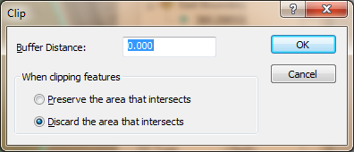

Click **OK**.

Go back to your map. Click in the Colby Green polygon with the Edit tool. Note that the Selection Chip tool does not appear. This indicates that you have no overlapping polygons.

Next, you will label the new polygon Colby Green.

Using the same procedures outlined in Step 7, name the new polygon **Colby Green**.

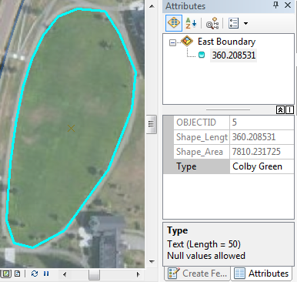

In the next step, you will add a polygon to the perimeter of the existing polygon

1. Creating adjoining polygons

**Zoom** to the campus quad.

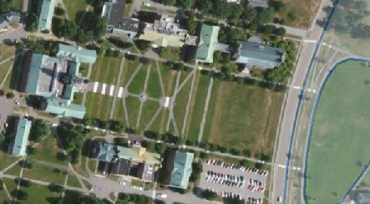

Next, you will digitize the quad and ensure that the new polygon shares the boundary with the existing East Boundary polygon. This will require using another specialized construction tool: [Auto Complete Polygon](http://help.arcgis.com/en/arcgisdesktop/10.0/help/index.html#//001t00000034000000.htm).

In the Create Features window, select **Auto Complete Polygon** from the Construction Tools list.

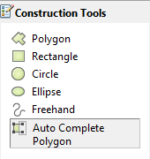

Start the new polygon by snapping the first vertex to the existing East Boundary polygon then digitize the quad area. Make sure that the last vertex snaps to the East Boundary polygon.

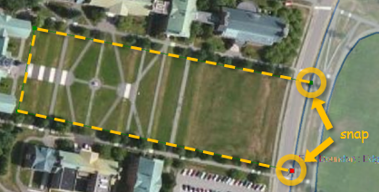

Don’t forget to end the sketch by **right-clicking** and selecting **Finish Sketch** (or alternatively, press the **F2** key).

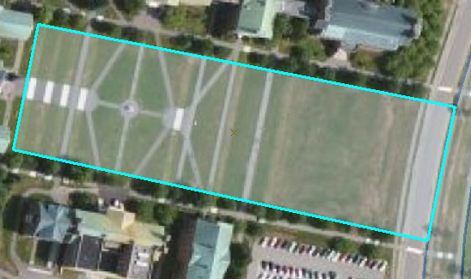

In the **Attribute** editor, name the new polygon “**Quad”**.

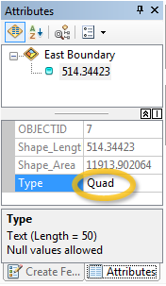

You are now done editing the East Boundary layer. You will save and stop your edit session.

From the Editor toolbar, select **Save Edits**.

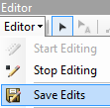

From the Editor toolbar, select **Stop Editing**.

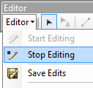

Next you will edit polyline features.

1. Setting up the snapping environment

You have already been exposed to *snapping* when you split the polygon in an earlier step. By default, ArcMap is setup to snap to points, polyline endpoints, vertices and edges. When you are in an edit session, the snapping toolbar can be accessed from the Editor toolbar (**Editor >> Snapping >> Snapping Toolbar**).

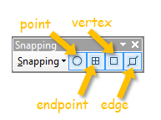

Turn **off** the **East Boundary** layer and turn **on** the **Roads layer**.

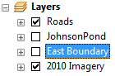

**Right-click** on the **Roads** layer and select **Edit Features >> Start Editing**.

If the Snapping Toolbar is not already open go to the Editor toolbar, select **Editor >> Snapping >> Snapping Toolbar.**

In the Snapping toolbar, **turn off** snapping for **points** and **endpoints**.

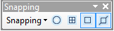

1. Adding vertices to a polyline

Using the Editor toolbar’s **Edit Tool**  select Mayflower road.

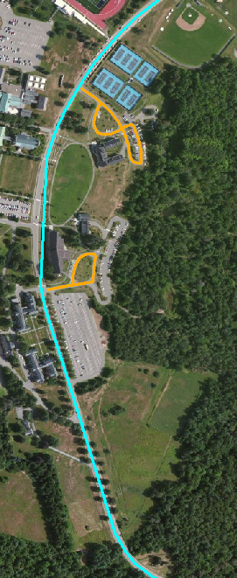

From the Editor toolbar, select the **Edit Vertices** tool.

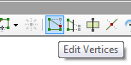

This brings up the Edit Vertices toolbar.

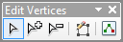.

In the Edit Vertices toolbar, select **Add Vertex**.

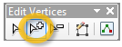

In the Data View window, **zoom in** on the section of the road near the Colby Green lawn and the Diamond building.

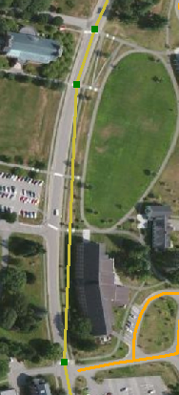

Note that a road segment does not accurately depict the true shape of the road represented in the aerial image. You will add **four** vertices to that segment

In the Data View window, **add** **four** **vertices** to the line segment. Their exact locations do not matter.

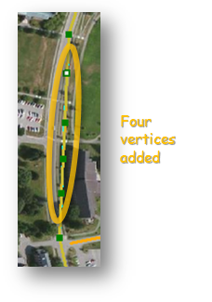

Next, you will move the vertices to the actual road outline.

Select the **Modify Sketch Vertices** tool from the Edit Vertices toolbar.

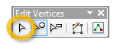

Next **move** the four new vertices in such a way that the polyline feature follows the road.

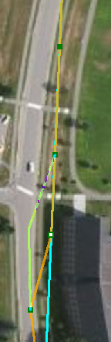

When complete, press the **F2** key (this completes the edit sketch).

Your modified polyline feature should look like this:

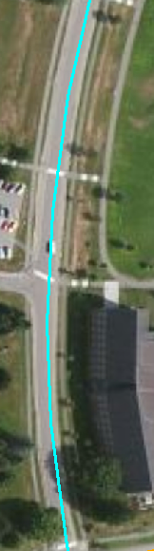

**Clear** all **selections** (click on  in the tool toolbar).

1. Extending line segments

Select **Alumni Lot** from the **Bookmarks** pull-down menu.

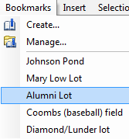

Notice that the Alumni Lot access road is not connected to the Mayflower Hill drive line segment. This needs to be corrected. One option is to move and snap the access road *end-node* to the Mayflower Hill road segment (while ensuring that the snap-to-edge is enabled). Another approach is to use one of ArcGIS’ advanced tools ([Extend](http://help.arcgis.com/en/arcgisdesktop/10.0/help/index.html#/to_an_intersection_with_another_line_Extend/001t0000002v000000/)) to force the alumni lot access road to extend and snap to Mayflower Hill road.

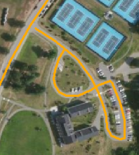

From the **Editor** toolbar, select **Editor >> More Editing Tools >> Advanced Editing**.

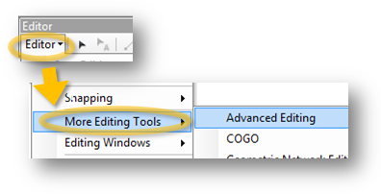

**Select** Mayflower Hill drive.

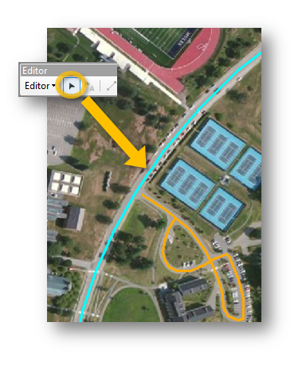

Note that when a line segment is selected, all of the Advanced Editing tools become active.

From the **Advanced Editing** toolbar, select the **Extend** tool.

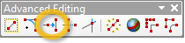

Click anywhere along the tail-end of the Alumni lot access road. This action will extend that segment to the selected Mayflower Hill road line segment.

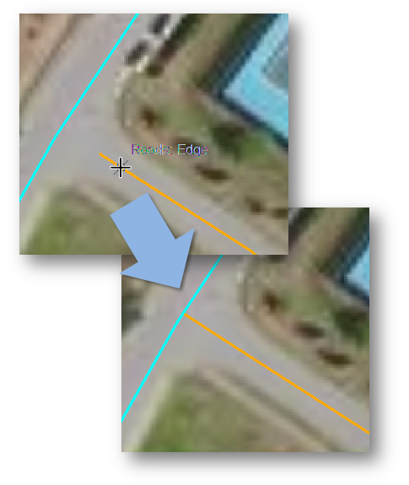

1. Adding polyline segments

Next, you will add a road segment to the Alumni lot polyline feature. The new segment will need to connect to the existing road segment. This will require that the proper snap options are set.

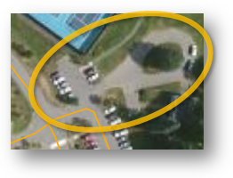

In the **Snapping** toolbar, ensure that the **Edge Snapping** and **Vertex Snapping** options are both active.

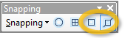

You will also want the new sketch to [snap to itself](http://help.arcgis.com/en/arcgisdesktop/10.0/help/index.html#//001t00000042000000.htm).

In the **Snapping** toolbar, select **Snapping >> Snap to Sketch**.

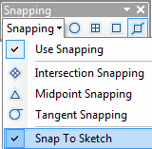

In the **Create Features** window, select the **line** **construction** tool (too see the tools the layer to be edited must active)

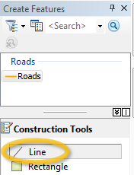

Hover the cursor anywhere over the existing line feature until it snaps (see graphic below).

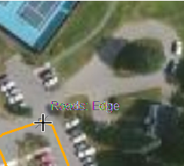

Create your first vertex on the existing line, and then continue digitizing the loop. Make sure that the other end of the line segment snaps to itself once it completes the loop.

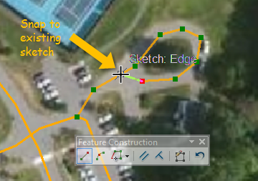

Don’t forget to properly end the sketch (i.e. **right-click >> Finish Sketch** or press the **F2** key).

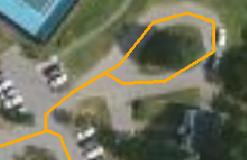

1. On your own

Next you will modify the Diamond/Lunder lot access road using the skills learned in Steps 12 and 13.

From the **Bookmarks** pull-down menu, select **Diamond/Lunder lot**.

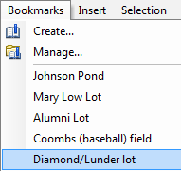

You will add/modify the feature(s) such that the final layer looks like the following:

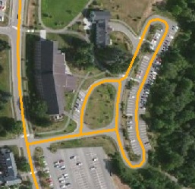

When done, **save** then **stop** your edit session and **save** ArcMap.

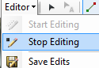

 Manuel Gimond, last modified on 8/26/2013